English Club Talent Hunt Report
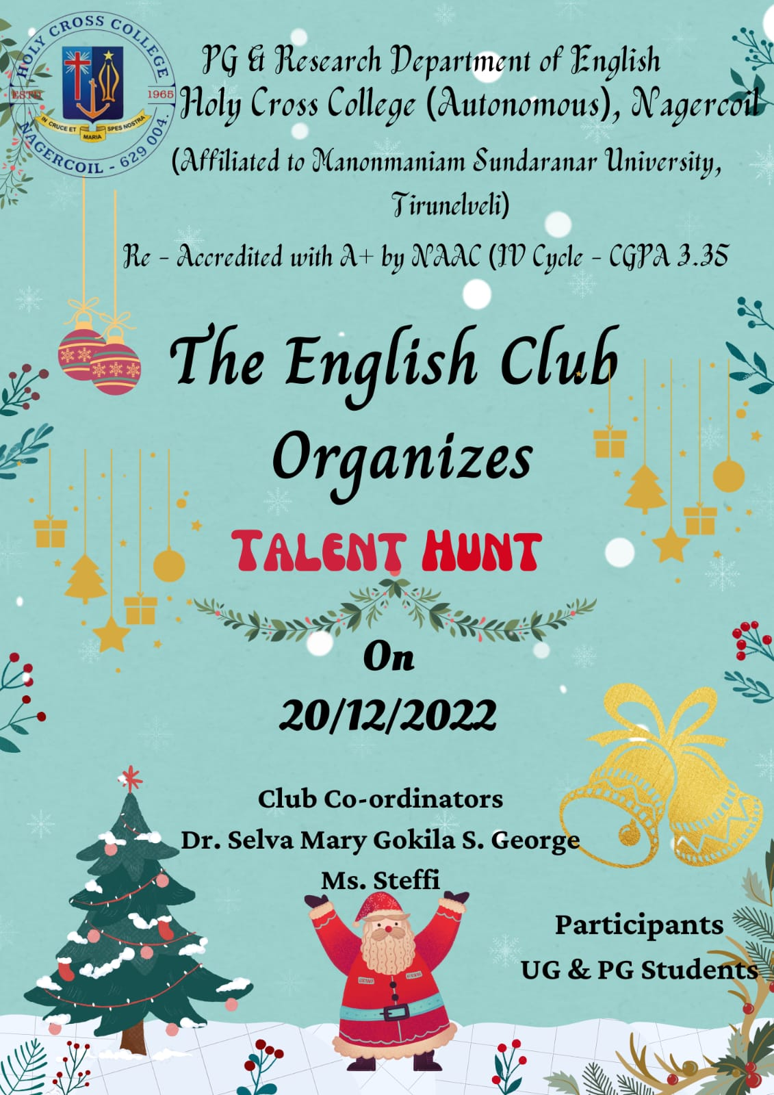
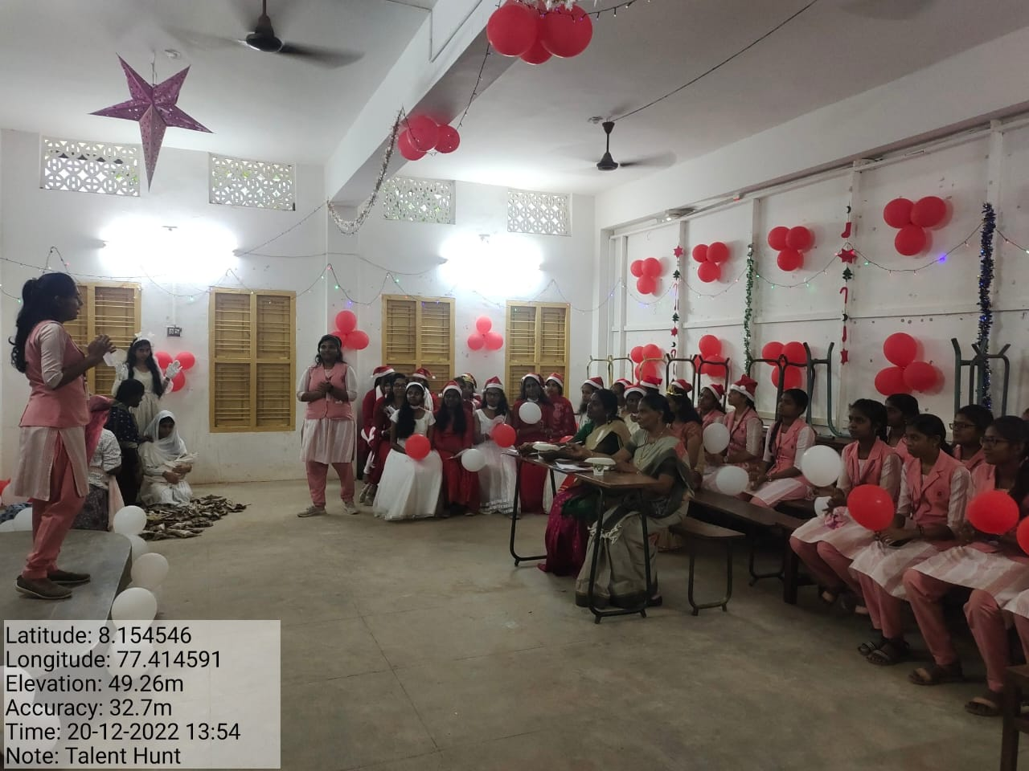
The PG and Research Department of English organised Talent Hunt on 20.12.2022 in view of Christmas. Students of UG and PG participated actively. They all communicated a message through their performances like skit, dance, and carol. Dr. M. Mary Helen Stella, Assistant Professor of Commerce and Dr. P.T. Anbu Hannah Dora, Assistant Professor of French were the judges for the interdepartmental X’mas competitions. The judgement was based on Class decoration, Costume, Neatness, Presentation and Creativity. II M.A students won the I prize, II B.A students won the second prize, and III B.A students won the third prize.

